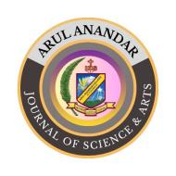
ARUL ANANDAR JOURNAL OF SCIENCE & ARTS (AAJSA)
Reviewer Evaluation Form

Manuscript ID | :
Manuscript Title | :

SECTION A: GENERAL ASSESSMENT
5 – Excellent; 4 – Very Good; 3- Good; 2 – Average; 1- Poor

CRITERIA | SCORE
Originality of the Research
Relevance to the Journal Scope
Clarity and Organization
Methodology and Analysis
Validity of Results and Interpretation
Quality of Figures, Tables, and References
Contribution to the Field

SECTION B: DETAILED COMMENTS
- Comments to the Author

- Comments to the Editor

SECTION C: RECOMMENDATION

☐ Accept as it is
☐ Minor Revision
☐ Major Revision
☐ Reject

Response:

Reviewer’s Name | :
Designation | :
Institutional Address | :
Date | :

